On the following pages you will find a press release from the Western Association of Fish and Wildlife Agencies, WAFWA, which highlights results of a recent trend analysis they completed for greater sage-grouse range-wide. Below is a figure showing the range-wide trends in sage-grouse lek counts from 1965-2015. This is the population time series that is referenced throughout the following press release. If you’d like to see the entire report I’ve also uploaded a pdf on the *Readings* page, however you should be able to complete the final question of the assignment using this only figure and the press release.

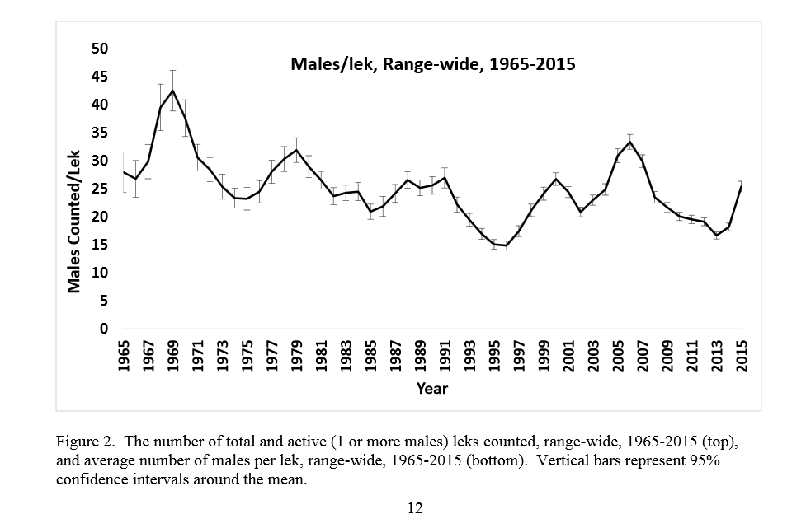

**FOR IMMEDIATE RELEASE**

Aug. 17, 2015

**Media Contact:** San Stiver

[928.899.3732](tel:928.899.3732), san.stiver@wafwa.org

**WAFWA REPORT DOCUMENTS GREATER SAGE-GROUSE POPULATION REBOUND**

*Latest population trend report released to USFWS shows reversal of recent declines*

The Western Association of Fish and Wildlife Agencies ([WAFWA](http://www.wafwa.org/)) released a final report today on greater sage-grouse population trends across the Western United States, and the results are encouraging. While the report shows that sage-grouse populations vary greatly over time, the number of male birds documented this year has rebounded significantly from a recent low in 2013. Scientists make population estimates based on the number of male birds counted on traditional mating areas, or leks. The number of males counted on leks has increased 63% since 2013. The greater sage-grouse is the largest native grouse species in the North America and its range covers 11 western states and portions of two Canadian provinces.

The report was prepared to provide scientific information to the U.S. Fish and Wildlife Service (USFWS) in advance of the upcoming Endangered Species Act listing decision on greater sage-grouse, which is expected to be made by the end of Sep. 2015. It summarizes and analyzes the information contained within more than a dozen databases from the 11 western states where sage-grouse populations can be found. The databases include information gathered from 1965-2015. Those studies document the number of males counted on traditional mating areas (leks) each spring. These counts have been conducted by state wildlife agencies with assistance from partners and volunteers for more than 50 years.

“The recent population peak in 2006 of over 33 males per lek was the highest level since 1970,” said San Stiver, Sage-Grouse Coordinator for WAFWA. “The lowest count was 16.7 in 2013, but those numbers rebounded sharply in the last two years to 25.5 males per lek.”

The report also documents trends in the rate of population change. WEST, a statistical and environmental consulting firm based in Cheyenne, Wyoming performed the analysis. WEST employed sophisticated modeling techniques and found that range-wide populations have declined at a rate of about 0.8% per year since 1965, but that the rate of decline has slowed in recent years.

WEST also evaluated trends in sage-grouse strongholds and compared those to trends at the edges of the range, and found these areas of highest sage-grouse density were generally holding up very well and most of the decline was at the periphery of the range.

This report is the newest development in a long history of collaborative conservation efforts for the bird. WAFWA has been actively involved in these efforts since 1954. Through the legislatures of all 11 states, natural resource agencies have invested more than $200 million in conservation actions to protect sage-grouse during the last decade. Besides the state natural resource agencies and the USFWS, others involved in these conservation efforts include the Natural Resource Conservation Service, Bureau of Land Management, US Forest Service, US Geological Survey, non-government organizations and private landowners. The 2006 [WAFWA Greater Sage-Grouse Conservation Strategy](http://wafwa.05-one.net/Documents%20and%20Settings/37/Site%20Documents/News/GreaterSage-grouseConservationStrategy2006.pdf) was developed to coordinate conservation efforts across the bird’s range and it calls for no net loss of sage-grouse habitat or populations.

“This latest report shows sage-grouse populations are still doing well across much of their range,” said Virgil Moore, Director of Idaho Department of Fish and Game and director liaison of WAFWA’s Sage-Grouse Initiative. "While this report is good news to all who treasure this bird, we know that long-term ongoing conservation and management must continue into the future for greater sage-grouse on its current range."

In 2015, 85,674 male sage-grouse were counted on 3,559 leks. Scientists note that the locations of all sage-grouse leks are not known, biologists are not able to count every lek that is known, and not all males are detected during counts so the number counted represents a minimum number of males known alive. This number of male grouse extrapolates to a spring breeding population of 424,645 on known leks.

This report describes trends in sage-grouse populations from 1965 to 2015, but it does not attempt to explain the causes for those population fluctuations.  “While that’s an important question, it was beyond the scope of this latest study,” said Tom Remington, who led WAFWA’s efforts on the report. “The USFWS will be evaluating that to some degree as part of their listing determination.”

Organized in 1922, the **Western Association of Fish and Wildlife Agencies** (WAFWA) represents 23 states and Canadian provinces, an area covering nearly 3.7 million square miles of some of America's most wild and scenic country. WAFWA supports and promotes the principles of sound resource management and the building of partnerships at the regional, national and international levels in order to enhance wildlife conservation efforts and the protection of associated habitats in the public interest. ###

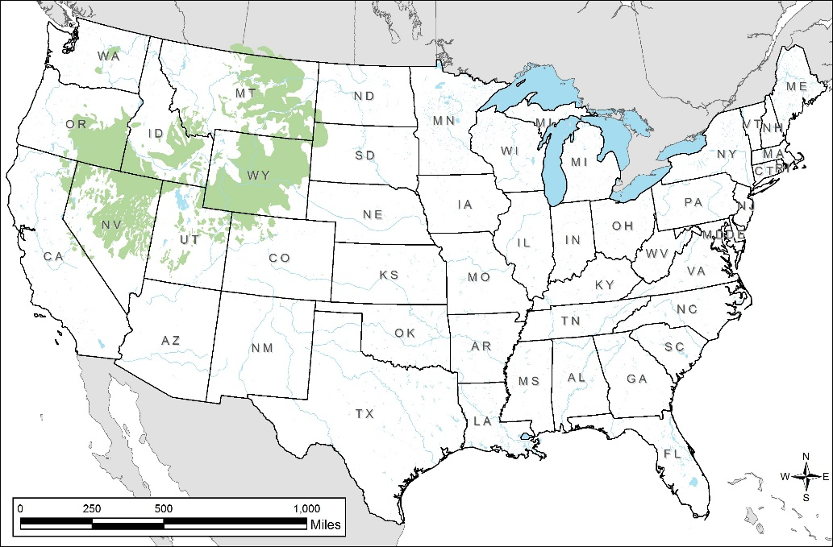

**Greater sage-grouse distribution in the United States**

Map courtesy Colorado Parks and Wildlife

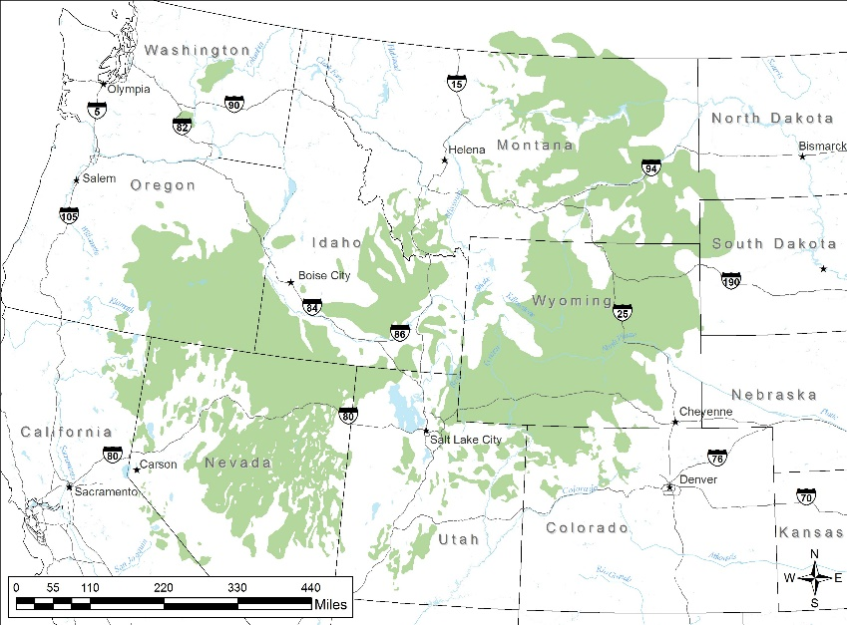

**Greater sage-grouse distribution in the western United States**

Map courtesy Colorado Parks and Wildlife

Links:

All WAFWA news releases can be found [HERE](http://www.wafwa.org/news/)

Greater sage-grouse population report [HERE](http://www.wafwa.org/Documents%20and%20Settings/37/Site%20Documents/News/Lek%20Trend%20Analysis%20final%208-14-15.pdf)

[WAFWA Greater Sage-Grouse Conservation Strategy](http://wafwa.05-one.net/Documents%20and%20Settings/37/Site%20Documents/News/GreaterSage-grouseConservationStrategy2006.pdf)

[USFWS Fact Sheet on Greater Sage-Grouse](http://www.fws.gov/greatersagegrouse/factsheets/GreaterSageGrouseCanon_FINAL.pdf)